2025 Solns

Multiple Choice

Question 1
Correct answer: . B
The use of waste byproducts as fertilizer is limiting the degree of waste and adding to the green credentials of the process

Question 2
Correct answer: . B
The gas produced from the waste is biogas with the main ingredient being methane. The methane burns in the generator to form CO₂ and water. Methane is a gas and is not soluble in water.

Question 3
Correct answer: . D
44g of CO₂ is 1 mole. If 0.25 mol of fuel produces 4 times as much CO₂ then the fuel has four carbon atoms. This is butane.

Question 4
Correct answer: . C
The reaction shown is endothermic – energy is required to make the reaction proceed. The energy required to break the bonds is greater than the energy released when bonds form.

Question 5
Correct answer: .B
The reverse reaction will have a negative value of ΔH. Option B has half the coefficients of the equation in the question, there the magnitude of the ΔH is half of 96 kJ.

Question 6
Correct answer: .C
In fermentation, C₆H₁₂O₆ forms CH₃CH₂OH. Assigning O a charge of 2- and H +, the oxidation of carbon in glucose can be determined to be 0 and its oxidation state in ethanol is 4+

Question 7
Correct answer: . A
With the half-equation of zinc being Zn(s) + 2OH⁻(aq) Zn(OH)₂(aq) + 2e, the electrons are travelling from the zinc electrode to the oxygen electrode.

Question 8
Correct answer: D
The other half-equation is O₂(g) + 2H₂O(l) + 4e 4OH⁻(aq), leading to option D as the correct answer.

Question 9
Correct answer: . B
Both option B and C are balanced but option B operates in an alkaline environment, matching the KOH in the diagram.

Question 10
Correct answer: . C
The efficiency of this cell relies upon the action of the catalyst on glucose. If the cell is heated significantly, the heat will denature the enzyme, lowering the cell efficiency.

Question 11
Correct answer: . A
This cell matches the electrolysis of concentrated NaCl shown in most text books. In a dilute solution water will react at both electrodes but in concentrated solutions, the Cl ions react before water. The Cl⁻ ions are oxidised to Cl₂ gas at the anode and water is reduced at the cathode.

Question 12
Correct answer: . D
Combining the oxidation of Cl⁻ with the reduction of water from -0.83 V produces an overall equation of
2Li⁺(aq) + 2Cl⁻(aq) + 2H₂O(l) H₂(g) + Cl₂(g) + 2LiOH(aq)

Question 13
Correct answer: . B
0.4 mol of electrons will produce 0.2 mol of H₂ and 0.2 mol of Cl₂. This is a toal of 0.4 mol of gas.
V= n x 24.8 = 0.4 x 24,8 = 9.92 L

Question 14
Correct answer: . A
The halving of the volume will double the green intensity. The system moves in the forward direction to relieve the pressure but the Cl₂ intensity will still finish with a higher concentration than before the change.

Question 15
Correct answer: . B
An increase in Cl₂, which is on the denominator will lower the value of Q.

Question 16
Correct answer: . C
No -OH bond of any kind but it has a carbonyl bond.

Question 17
Correct answer: A
The longest chain that includes the priority -OH group has five carbons. It is numbered from the carbon attached to the hydroxyl group. This makes the ethyl group on the second carbon and chlorine on the fifth. Branches are listed in alphabetical order.

Question 18
Correct answer: . A
Arachidonic acid has 4 C=C double bonds, so will react with 2.8 mol of iodine, higher than the other options.

Question 19
Correct answer: C
The area ratio is 1:2:3, which could match -OH, then CH₂ then CH₃ of ethanol. The shift values match as well as the splitting pattern.

Question 20
Correct answer: D
This pattern is characteristic of a compound with two Cl atoms. This gives the possibility of two ³⁵Cl atoms. or one of each ³⁵Cl, ³⁷Cl or two of ³⁷Cl.

Question 21
Correct answer: A
The tertiary alcohol is not oxidised.

Question 22
Correct answer: C
All three molecules should be polar due to the range and distribution of the electronegative O atoms. Their polarities, however, will not be equal.

Question 23
Correct answer: D
The molecule has very similar H and C environments but they are not exactly the same.

Question 24
Correct answer: D

Question 25
Correct answer: C
From left to right you have valine, glycine, serine and alanine

Question 26
Correct answer: C
The diagram shows a competitive inhibitor occupying the active site, blocking the substrate

Question 27
Correct answer: B
Multiple chiral centres are common in plant medicines and the number of enantiomers can become quite large.

Question 28
Correct answer: B
As the enzyme nears its optimal pH, the reaction time drops as in option B

Question 29
Correct answer: A
Heat exchangers are common in industry – if a reaction releases energy it is wise to put it to use.

Question 30
Correct answer: D
Unfortunately you are expected to read the preamble in the study design.

Section B

Question 1 (17 marks)

a. i. Substrate fits into active site of enzyme. Bonds in the substrate are weakened and products form. Site becomes free to act again. 3 marks
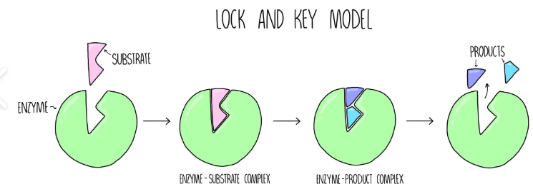

ii. High temperatures will denature the enzymes and the reaction rate will be very slow. 1 mark

iii. C₆H₁₂O₆(aq) 2C₂H₆O(aq) + 2CO₂(g). 1 mark

iv. atom economy = 2M(ethanol)x100/M(glucose) = 2 x 46 x 100/180 = 51.1% 2 marks

b. i. 240 mol of oil will bond with 3 x 240 molecules of ethanol = 720 mol
mass = 720 x 46 = 33.1 kg 2 marks

ii. The reaction also produces glycerol. If it a typical oil, it will contain a range of fatty acids, hence a range of biodiesel esters form. 2 marks

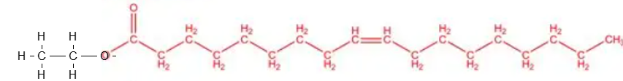
iii. 2 marks

c. i. Biomass that is formed from fruits or cereal is often high in carbohydrate. This makes it suitable for fermentation. If the biomass is more like manure and mixed material it is better suited to biogas. 2 marks

ii, CH₄(g) + 2O₂(g) CO₂(g) + 2H₂O(l) ΔH = - 890 kJ 2 marks

Question 2 (12 marks)
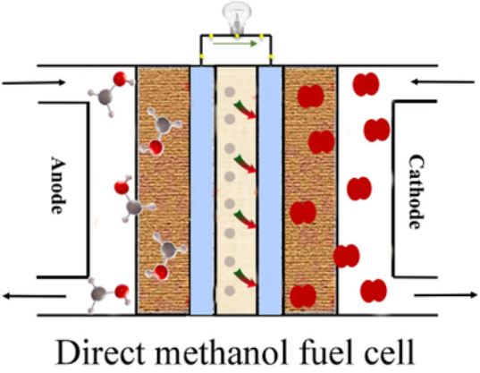

oxygen
methanol

a. i. see diagram 2 marks

ii. anode: CH₄O(g) + H₂O(l) CO₂(g) + 6H⁺(aq) + 6e 3 marks

cathode: O₂(g) + 4H⁺(aq) + 4e 2H₂O(l)

overall: 2CH₄O(g) + 3O₂(g) 2CO₂(g) + 4H₂O(l)

iii. H⁺ flow to the cathode . 1 mark

b. Methanol is not as explosive and can be handled and transported as a liquid – much safer. 2 marks

c. i. This diagram is for 1 mol of methanol 2 marks

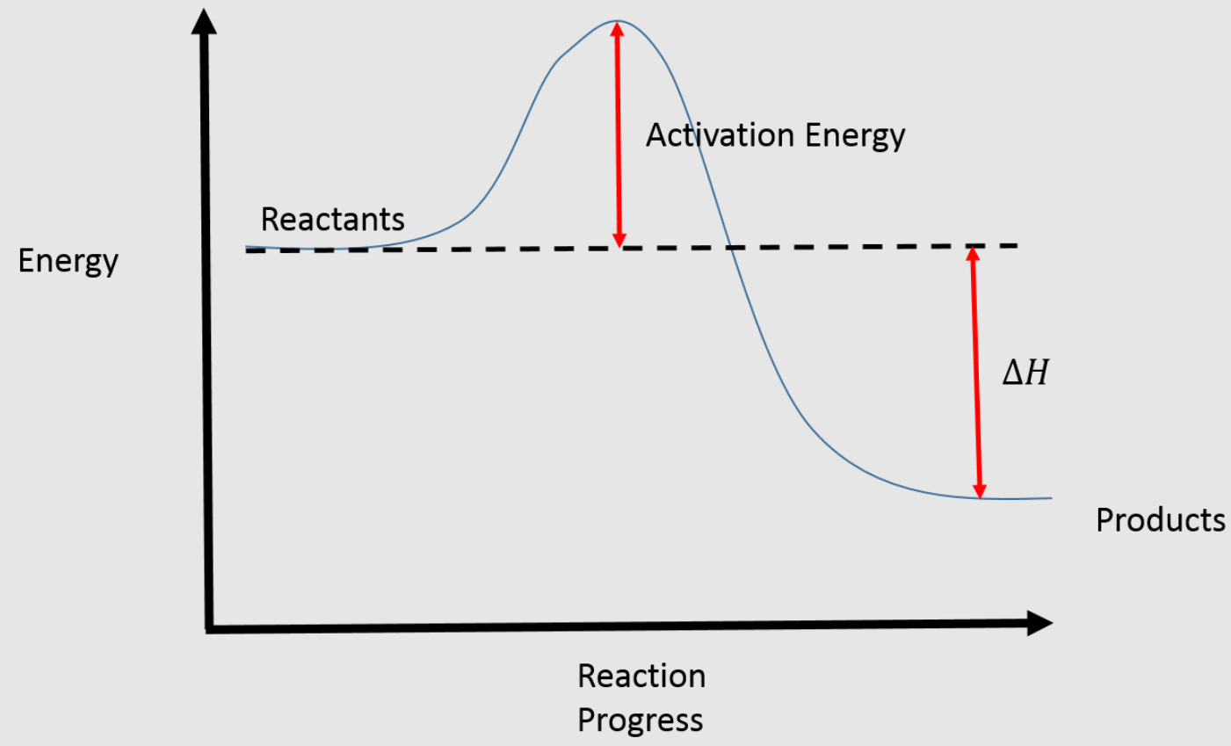
-726 kJ
0 kJ
ii. n(methanol) = 2.34/32 = 0.0731 mol
energy = 0.0731 x 726 = 53.1 kJ
65% efficient = 53.1 x 0.65 = 34.5 kJ
ΔT = 34500/(4.18x 440) = 18.8 = 19 ⁰C 2 marks

Question 3 (12 marks)
a. i. positive anode 1 mark

ii. anode: Au(s) Au³⁺(aq) + 3e (soln has Au³⁺) 3 marks

cathode: Au³⁺(aq) + 3e + Au(s)

overall equation: Au³⁺(aq) + Au(s) Au(s) + Au³⁺(aq)

b. total mass of gold = 2.8 x 1000 = 2.80 g
n(Au) = 2.8/197 = 0.00508
n(e) = 3 x n(Au) = 3 x 0.00508 = 0.0152 mol
Q = 0.0152 x 96500 = 1470 C
I=Q/t = 1470/24x3600 = 0.017 A 3 marks

c. The graph below has been obtained the gold cell above. It can be used to discuss Faraday’s
Laws for electrolysis.
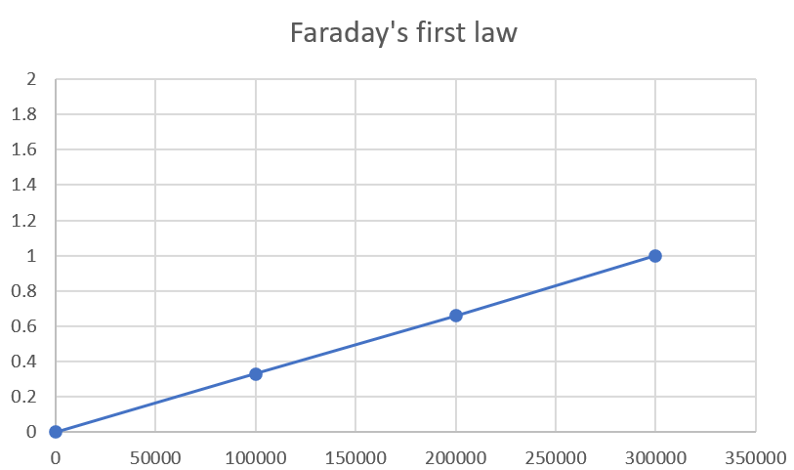

Mol metal

Ag

Cu

Au

charge

i. vertical – mole metal horizontal charge. 2 marks

ii. The mass of product deposited is proportional to the amount of charge. 2 marks

iii. see graph

Question 4 (8 marks)

a. i.
but-1-ene and but-2-ene 2 marks

ii. C₄H₈ + H₂O C₄H₉OH
b. i.

1 mark

ii. 3C₄H₉OH + Cr₂O₇²⁻ + 8H⁺ 3C₄H₃O + 2Cr³⁺ + 7H₂O 1 mark

iii. orange to green colour change of Cr 1 mark

iv. Fractional distillation to boil off the lower boiling point component, probably E 2 marks

Question 5 (10 marks)

a. i. Conclusion 1: O-H (acid) 2 marks

reason: Broad peak2500-3500 cm

Conclusion 2: C=O

reason: 1700 cm sharp peak

b. i. m/z parent ion is 86 => C₄H₆O₂ and must have 2 oxygen atoms 2 marks

ii. m/z base peak = 41, possibly C₃H₅⁺ 1 mark[

c. 173 ppm ester or carboxyl 2 marks

138 ppm C=C double bond
d. correct formula 3 marks
carboxyl group and C=C double bond
4 C environments
4 H environments
(take note of the added commentary on the Qn itself re proton-NMR

Question 6 (12 marks)
a. i. serine, alanine and threonine 1 mark
ii. 1 mark

iii. 6 1 mark

iv. The secondary structure forms from hydrogen bonding between different parts of the same molecule. The hydrogen bonding is based on the N-H and C=O bonds of the amide links. 2 marks

b. Compare the action of inorganic catalysts and enzymes.
Both increase the rate of a reaction. Both are unchanged in the reaction. The rate of their reaction increases as temperature increases from low values (<35 C). In your response,
Enzymes are more heat sensitive than inorganic catalysts as they can be denatured. Some inorganic catalysts can work for more than one reaction. 4 marks

Question 7 (11 marks)
a.
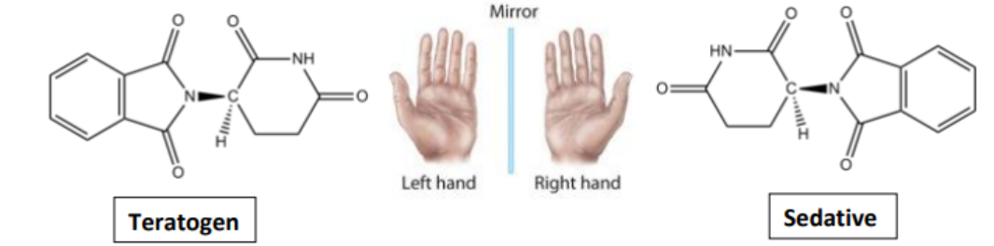
i. Use an asterisk to identify the chiral carbon in the teratogen. 1 mark

ii. No, the melting point of both enantiomers will be the same. 2 marks

iii. The new solvent is working. A typical solvent in HPLC A does not separate the two (only one peak) but the second solvent has an extra peak – the two enantiomers have different retention times. 2 marks

b. i. 2MnO₄⁻(aq) + 5H₂O₂(aq) + 6H⁺(aq) 2Mn²⁺(aq) + 5O₂(g) + 8H₂O(l) 2 marks

ii. n(MnO₄⁻) = c x V = 0.15 x 0.0024 = 0.00036 mol
n(H₂O₂) = n(MnO₄⁻) x 5/2 = 0.0009 mol
c(H₂O₂⁻) = 0.0009/0.02 = 0.045 M
original = 0.45 x 1000/300 = 0.150 M 3 marks

iii. The mean titre is very small. This limits accuracy. The H₂O₂ should be diluted less before titration. 1 mark

Question 8 (9 marks)
a. i. Diastase will have an optimum pH where the rate of reaction is highest. 1 mark

ii. The optimum pH of diastase is around pH 7. 1 mark

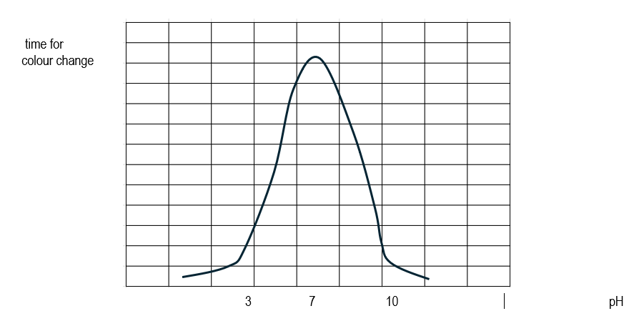
iii.

3 marks

b. i. The enzyme diastase has an optimum operating temperature. 1 mark

ii. At very low temperatures diastase has little enzyme activity, too few collisions. The reaction rate increases with temperature up to a point but then it starts to denature. If it gets as high as 100 ⁰C it is completely denatured. 3 marks

Question 9 (6 marks)
a. 3 marks
Graph A Graph B Graph C



rate
time
yield

pressure
pressure
pressure

b.
K = $\frac{[SO_{3}]^{2}}{[SO_{2}]^{2}[O2_{}]}$ = 2²/1²x1 = 4 M⁻¹ 3 marks

The volume is doubled, each concentration is immediately halved:

[SO₃] = 1.0 M [SO₂] = 0.5 M [O₂] = 0.5 M

K is now = 1²/0.5²x0.5 = 16 M
The system will need to move in the reverse direction to reach equilibrium.

